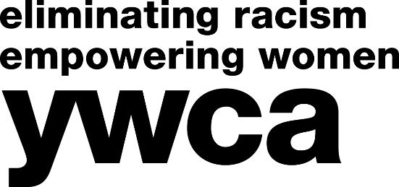

**TEAM REGISTRATION FORM** *(Minimum 2 players; Maximum 8 players)*

Team Name: _______________________________________________________________________________

|  |  |  |  |
| --- | --- | --- | --- |
| **PLAYER NAME** | **ADDRESS** | **EMAIL** | **PHONE** |
| *Team Captain/Main Contact* |  |  |  |
|  |  |  |  |
|  |  |  |  |
|  |  |  |  |
|  |  |  |  |
|  |  |  |  |
|  |  |  |  |
|  |  |  |  |

**Each player is asked to collect a minimum of 5 pledges in order to play.** Please make sure all team members have a copies of the pledge form, pledge receipts, and instructions/FAQs. All forms and information are available on our website at [www.ywca-northeasternny.org/trivia](http://www.ywca-northeasternny.org/trivia) or by emailing Kerrie at [KWolf-Piechota@ywca-neny.org](mailto:KWolf-Piechota@ywca-neny.org).

**Please send completed team registration forms by November 1, 2017. *Pledge forms are also due on November 1, 2017.**

Kerrie Wolf-Piechota, Development Assistant

YWCA NorthEastern NY, 44 Washington Avenue, Schenectady, NY 12305

KWolf-Piechota@ywca-neny.org • 518-374-3394 ext. 123

3rd Trivia Night Competition & Fundraiser

Thursday, November 9, 2017 • 5:30 PM Doors Open • 6:30 PM Trivia  
Rotterdam Elks Lodge • 1152 Curry Road, Schenectady

**NorthEastern NY**