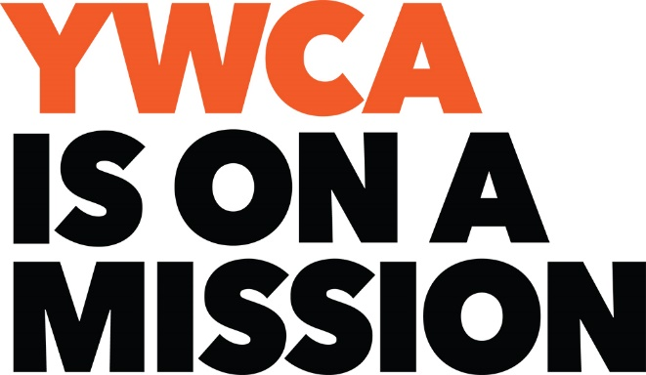

January 2, 2018

Dear Friend:

Each year, the YWCA NorthEastern NY honors women who exemplify a spirit of excellence in their community, in their work and in their lives. We continue in 2018 with the induction of another group of outstanding women into the Academy of Women of Achievement. Membership in this inspirational group of leaders is both an honor and a privilege. As you know, the Women of Achievement Award is one of the most prestigious awards given locally to women who have demonstrated a commitment to empowering women and eliminating racism. The YWCA has a long history of recognizing women who embody the ideals of passion, dedication and selfless service to their communities.

We invite you to join the 2018 Honorary Committee as we honor these incredible women as well as celebrate 35 years of this amazing event. The YWCA NorthEastern NY’s 35th Women of Achievement Celebration & Fundraiser will be held at the Glen Sanders Mansion in Scotia on March 8, 2018. We ask you to help us in making this year’s event the most successful yet by becoming a member of the Honorary Committee ($175). Our goal is to have 35 honorary committee members, making it the most ever and honoring 35 years of the many amazing inductees. Your Honorary Membership includes dinner and your name on the invitation, program and PowerPoint presentation.

Nominations for the Women of Achievement award are being accepted until January 15, 2018. Applications can be accessed from our web site, www.ywca-northeasternny.org.
Responses and payments received by January 17, 2018 will be published on the invitation and program booklet. Deadline is February 22, 2018 for the program booklet. Please contact Jo-Anne Rafalik at the YWCA, 518-374-3394 ext. 105 or jrafalik@ywca-neny.org with any questions. Thank you in advance for accepting our invitation to support this event and we look forward to seeing you on March 8th.
Sincerely,
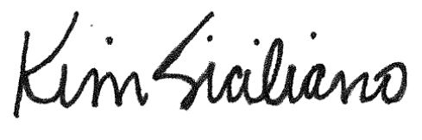

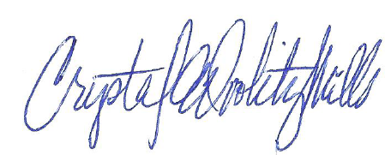

Crystal Doolity-Mills Kim Siciliano
Women of Achievement, Chair Executive Director
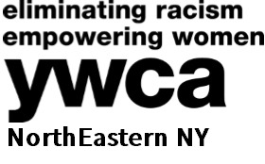

2018 Honorary Committee
Women of Achievement Celebration & Fundraiser
To be included on the invitation and program book,
email me, jrafalik@ywca-neny.org, the information by January 17, 2018.
To be included in our program book only, responses are needed by February 22, 2018.
 | I accept your invitation to be on the Honorary Committee for the 2018 Women of Achievement Celebration, $175.
 | I regret that I am unable to accept your invitation at this time but please accept my donation.
 | Amount enclosed: $ Please make check payable to: YWCA NorthEastern NY
 | Credit card information: |  |  | VISA |  | MASTERCARD
 |  |  |  | DISCOVER |  | American Express
 | Name:
 | Card No: |  |  |  |  |  | Exp. Date:
 | Signature:
 | Please print the proper listing of your name for the Invitation and program book:

Mail to:
YWCA NorthEastern NY
Jo-Anne Rafalik
44 Washington Ave.
Schenectady, NY 12305

