YWCA NorthEastern NY

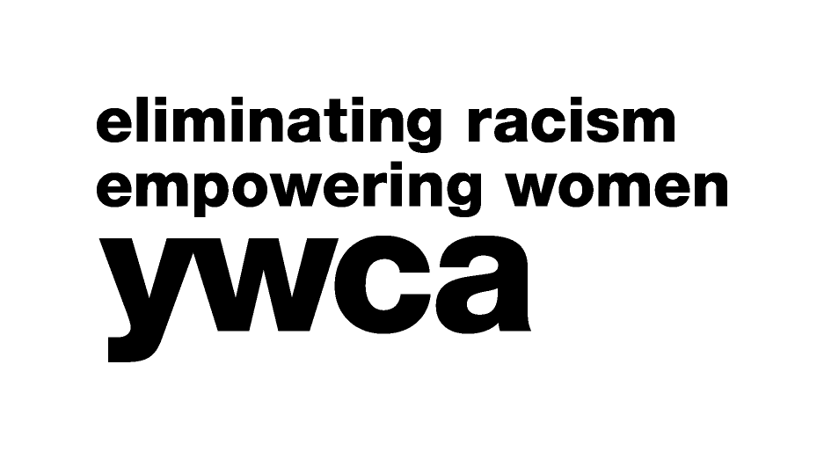

Women of Achievement

Contract for 2018 Dinner Program Book

This advertising contract is made between the YWCA NorthEastern NY and:

Advertiser’s Company/Organization: ________________________________________

Address: ______________________________________________________________
______________________________________________________________

Contact Person: ___________________________________Phone:________________

Email Address: _________________________________________________________

Ad Size Desired: ______________________ Payment enclosed: _________________

Ad sizes and rates: Width and Depth Price

Full Page 4 1/2” x 7 1/2” $150

Three Quarters Page 4 1/2” x 5 3/5” $125

One Half Page 4 1/2” x 3 3/4” $100

One Quarter Page 4 1/2” x 1 9/10” $75

Copy Deadline: February 21, 2018

Please attach your ad copy and return to:
YWCA NorthEastern NY, 44 Washington Avenue, Schenectady, NY 12305-1799 or email to: funddevelopment@ywca-neny.org (please send pdf version with an attached company logo).
For more information, call Jo-Anne Rafalik at the YWCA, 518-374-3394 (ext. 105).

