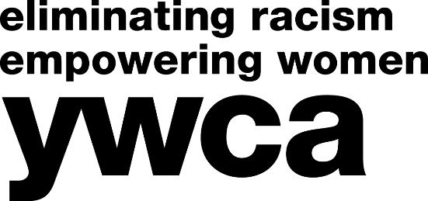

**TEAM REGISTRATION FORM** *(Minimum 2 players; Maximum 8 players)*

This year, we are making our trivia fundraiser even easier to participate in! There are 2 options for registration: **Option 1**: your team is challenged to raise at least $400 through collectively gathering flat donations. Because it is a collective team effort, individual players are not responsible to pay any particular amount, but may contribute to their team’s donation total if they do not wish to seek donations or even in addition to collecting donations. **Option 2**: each player on the team pays a fee of $35 to play.   
  
Keep in mind, the team that raises the most money will win a minimum of $250 in gift cards/prizes! The Team Donations method is not required, but it is very much appreciated! The more that teams compete to raise the most money, the more that you are helping provide much needed programs and services to our community.

Additional information and all forms can be found on our website at [www.ywca-northeasternny.org/trivia](http://www.ywca-northeasternny.org/trivia) or by emailing Kerrie at [KWolf-Piechota@ywca-neny.org](mailto:KWolf-Piechota@ywca-neny.org).

**Team Name:** _______________________________________________________________________________

|  |  |  |  |
| --- | --- | --- | --- |
|  | | | |
| **Player 1** *(Team Captain/Main Contact)* | | **Address** | |
|  | **Email** | | **Phone** |
|  | | | |
| **Player 2** | | **Address** | |
|  | **Email** | | **Phone** |
|  | | | |
| **Player 3** | | **Address** | |
|  | **Email** | | **Phone** |
|  | | | |
| **Player 4** | | **Address** | |
|  | **Email** | | **Phone** |
|  | | | |
| **Player 5** | | **Address** | |
|  | **Email** | | **Phone** |
|  | | | |
| **Player 6** | | **Address** | |
|  | **Email** | | **Phone** |
|  | | | |
| **Player 7** | | **Address** | |
|  | **Email** | | **Phone** |
|  | | | |
| **Player 8** | | **Address** | |
|  | **Email** | | **Phone** |
|  | | | |

**Please send completed team registration forms by November 1, 2018.   
Team donations will be collected at the event.**

Kerrie Wolf-Piechota, Communications & Public Relations Manager

YWCA NorthEastern NY • 44 Washington Avenue • Schenectady, NY 12305

518.374.3394 x123 • KWolf-Piechota@ywca-neny.org

Thursday, November 8, 2018  
5:30 PM Doors Open • 6:30 PM Trivia  
Rotterdam Elks Lodge • 1152 Curry Rd, Schenectady

4th Trivia Night   
Competition & Fundraiser

**NorthEastern NY**